UPDATE OF THE NUCLEAR CRITICALITY SLIDE RULE CALCULATIONS
–
PLUTONIUM CONFIGURATIONS – DELAYED GAMMA

IDENTIFICATION NUMBER: SR-Pu-UNREFLECTED-GROUND-002
KEY WORDS: Slide rule, plutonium, delayed gamma

Introduction
In 1997, Oak Ridge National Laboratory published the reports “An updated Nuclear Criticality Slide rule” (ORNL/TM-13322/V1 and ORNL/TM-13322/V2), as a tool for emergency response to nuclear criticality accident. The “Slide Rule” is designed to provide estimates of the following:
- magnitude of the number of fissions based on personnel or field radiation measurements,
- neutron- and gamma-dose at variable unshielded distances from the accident,
- the skyshine component of the dose,
- time-integrated radiation dose estimates at variable times/distances from the accident,
- 1-minute gamma radiation dose integrals at variable times/distances from the accident,
- dose-reduction factors for variable thicknesses of steel, concrete, and water.
The Slide Rule provides estimates for five unreflected spherical systems that provide general characteristics of operations likely in facilities licensed by the US NRC. AWE (UK), IRSN (France), LLNL (USA) and ORNL (USA) began a long term collaboration effort in 2015 to update this document. Calculations for initial configurations were performed using modern tools such as MCNP, SCALE and COG.
This present document summarizes the input data necessary to calculate additional configurations that combine new fissile media (plutonium systems, §2.2) for the delayed gamma dose. It completes the specifications provided earlier in the document “UPDATE OF THE NUCLEAR CRITICALITY SLIDE RULE CALCULATIONS – PLUTONIUM CONFIGURATIONS”.

Description of the additional configurations

GEOMETRY
The geometry for the additional configurations, derived from the initial configuration of the slide rule (described in the document SR-U-UNREFLECTED-GROUND-001), is presented hereafter.
The geometry consists of a simple air-over-ground configuration with a source located at the center of a right-circular cylinder. The radius and the height of the air cylinder are 1530 m. With modern 3-D tools, a square with a half-side of 1530 m might be considered. The ground is modeled as 50 cm layer of concrete.
The figures 1 and 2 present the model to be calculated. Additional information is given in the following paragraphs.
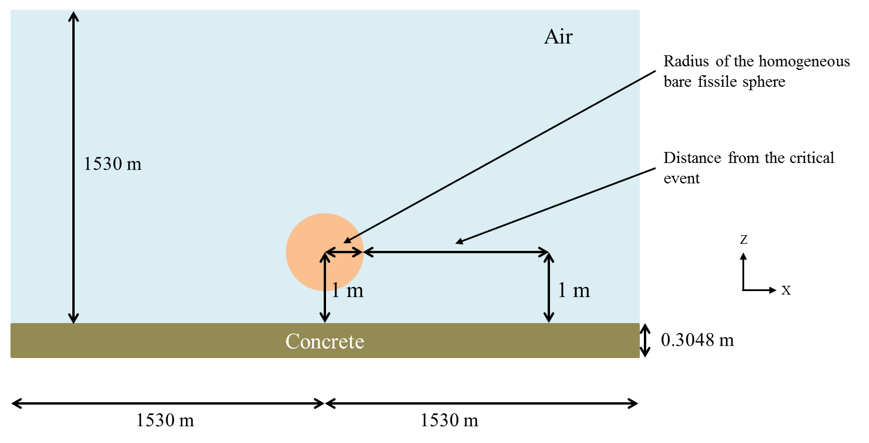
50 cm

Figure 1: X-Z Plan view of the configuration

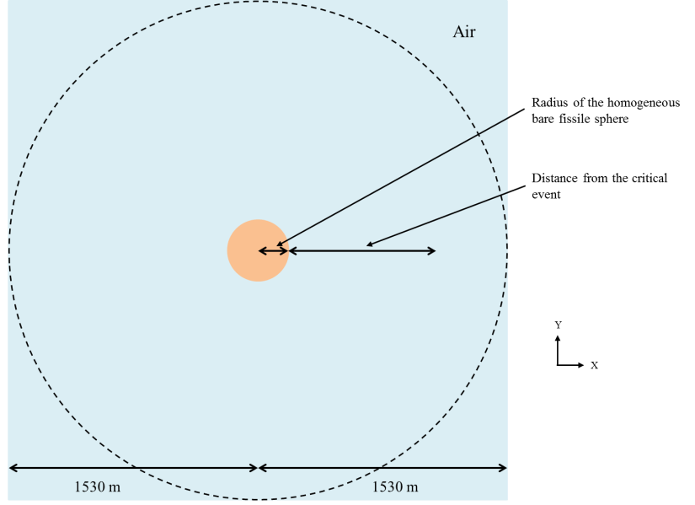

Figure 2: X-Y Plan view of the configuration

Plutonium systems (bare sphere)
Bare fissile media, with plutonium at various moderation ratios (H/Pu), is considered for the additional configurations. No reflector is considered around the sphere. The following table gives atomic concentration and critical radius for each media.
Table 1 : Compositions for the new fissile media, Pu
Number density  (atom/barn-cm) | Pu  (H/Pu = 0) | Pu  (H/Pu = 10) | Pu  (H/Pu = 100) | Pu  (H/Pu = 900) | Pu  (H/Pu = 2000)
Pu-239 | 5.00305E-02 | 5.88706E-03 | 6.58436E-04 | 7.40255E-05 | 3.33386E-05
O-16 | 0 | 2.94353E-02 | 3.29218E-02 | 3.33115E-02 | 3.33386E-02
H-1 | 0 | 5.88706E-02 | 6.58436E-02 | 6.66230E-02 | 6.66772E-02

The following table gives critical radii for these five media. They are calculated using MCNP6.1 with ENDF/B-VII.1 cross sections library.
Table 2 : Spherical radii for bare Pu configurations
 | Pu  H/Pu = 0 | Pu  H/Pu = 10 | Pu  H/Pu = 100 | Pu  H/Pu = 900 | Pu  H/Pu = 2000
Spherical radius (cm) | 4.93 | 12.53 | 15.36 | 19.50 | 29.17

Additional information

Source Strength and Spectra
The magnitude of each source is normalized to correspond to 1.E+17 fissions. This single information means that the intensity (nubar for neutron) and the energy and space repartition of prompt neutron and prompt gamma inside the sphere/cylinder has to be determined.

Delayed gamma
Delayed gamma doses rates are calculated assuming an instantaneous event. Then the expected dose rates for periods of 1, 5 and 10 s and 1, 5, 10, 50, 100, 500 and 1000 min after the event are tabulated for all five critical systems.
For these configurations, prompt doses have already been calculated. Only the delayed gamma need to be calculated.

Material and temperature Data
Only 3 media are simulated in the additional configurations:
- The air,
- One of the homogeneous plutonium spheres or cylinders,
- The ground made of concrete.
The atomic compositions of the air and the ground made of concrete are given in the following tables.
Table 3 : Composition of air.
Number density  (atom/barn-cm) | Air
N-14 | 4.00E-5
O-16 | 1.11E-5

Table 4 : Composition of concrete (SCALE material REG-CONCRETE).
Number density  (atom/barn-cm) | Concrete
Fe-54 | 2.02958E-05
Fe-56 | 3.18600E-04
Fe-57 | 7.35787E-06
Fe-58 | 9.79198E-07
H-1 | 1.37433E-02
Al-27 | 1.74538E-03
Ca-40 | 1.47412E-03
Ca-42 | 9.83851E-06
Ca-43 | 2.05286E-06
Ca-44 | 3.17205E-05
Ca-46 | 6.08254E-08
Ca-48 | 2.84359E-06
O-16 | 4.60690E-02
Si-28 | 1.53273E-02
Si-29 | 7.78639E-04
Si-30 | 5.13885E-04
Na-23 | 1.74720E-03

The temperature for all media and for all cases is 300 K (26.85 °C).

response function and detectors
Henderson flux to dose conversion factors were used for the initial configurations. These factors have a significant impact on the final dose and are likely to change in the future. That is why, the additional configurations should be performed using the following conversion factors:
- ANSI/HPS N13.3-2013 conversion factors (personal adsorbed dose per neutron unit fluence, Table B1 p. 18 and personal adsorbed dose per photon unit fluence, Table B2 p. 19),
- IAEA Technical Reports series n° 211 (1982) conversion factors (tissue kerma in air per neutron unit fluence, Table XIV pp. 138-139),
- ICRU report 47 (1992) conversion factors (air kerma in free air per photon unit fluence, Table A.1 p. 23).

Doses are calculated (see figure 1) at 1 m above the ground as a function of distance (between 30 cm and 1200 m) from the external surface of the source to the center of the detector. The detector used might be specified (type and geometry). By default, the detector geometry is a shape of a cylindrical shell with a square cross-section of 5 cm x 5 cm. The center of the detector is also at a height of 1 m above the ground.

RESULTS
The results will be written in the following tables. All options and data necessary to analyze the results (for instance, cross section libraries, kind of detector, use of variance reduction technique, etc.) might be specified.
For more clarity, a common file naming convention may be adopted. An example is the following:
- SR-Pu-S-UN-G1-C1-d03-DG10s.inp stands for:
- SR: slide rule,
- Pu: Plutonium,
- S: sphere,
- UN: unreflected (no shielding),
- G1: first case with a ground,
- C1: first case with the plutonium system (H/Pu = 0),
- d03: distance 0.3 m,
- DG10s: delayed gamma (after 10 seconds).

Table 5 : Delayed gamma doses for bare plutonium configuration – 1 second
Delayed gamma dose | Case 1 | Case 2 | Case 3 | Case 4 | Case 5
Distance (m) | Pu  H/Pu = 0 | Pu  H/Pu = 10 | Pu  H/Pu = 100 | Pu  H/Pu = 900 | Pu  H/Pu = 2000
0.3
0.5
1
2
5
10
20
50
100
200
300
500
700
1000
1200

Table 6 : Delayed gamma doses for bare plutonium configuration – 5 seconds
Delayed gamma dose | Case 1 | Case 2 | Case 3 | Case 4 | Case 5
Distance (m) | Pu  H/Pu = 0 | Pu  H/Pu = 10 | Pu  H/Pu = 100 | Pu  H/Pu = 900 | Pu  H/Pu = 2000
0.3
0.5
1
2
5
10
20
50
100
200
300
500
700
1000
1200
Table 7 : Delayed gamma doses for bare plutonium configuration – 10 seconds
Delayed gamma dose | Case 1 | Case 2 | Case 3 | Case 4 | Case 5
Distance (m) | Pu  H/Pu = 0 | Pu  H/Pu = 10 | Pu  H/Pu = 100 | Pu  H/Pu = 900 | Pu  H/Pu = 2000
0.3
0.5
1
2
5
10
20
50
100
200
300
500
700
1000
1200

Table 8 : Delayed gamma doses for bare plutonium configuration – 1 minute
Delayed gamma dose | Case 1 | Case 2 | Case 3 | Case 4 | Case 5
Distance (m) | Pu  H/Pu = 0 | Pu  H/Pu = 10 | Pu  H/Pu = 100 | Pu  H/Pu = 900 | Pu  H/Pu = 2000
0.3
0.5
1
2
5
10
20
50
100
200
300
500
700
1000
1200
Table 9 : Delayed gamma doses for bare plutonium configuration – 5 minutes
Delayed gamma dose | Case 1 | Case 2 | Case 3 | Case 4 | Case 5
Distance (m) | Pu  H/Pu = 0 | Pu  H/Pu = 10 | Pu  H/Pu = 100 | Pu  H/Pu = 900 | Pu  H/Pu = 2000
0.3
0.5
1
2
5
10
20
50
100
200
300
500
700
1000
1200

Table 10 : Delayed gamma doses for bare plutonium configuration – 10 minutes
Delayed gamma dose | Case 1 | Case 2 | Case 3 | Case 4 | Case 5
Distance (m) | Pu  H/Pu = 0 | Pu  H/Pu = 10 | Pu  H/Pu = 100 | Pu  H/Pu = 900 | Pu  H/Pu = 2000
0.3
0.5
1
2
5
10
20
50
100
200
300
500
700
1000
1200
Table 11 : Delayed gamma doses for bare plutonium configuration – 50 minutes
Delayed gamma dose | Case 1 | Case 2 | Case 3 | Case 4 | Case 5
Distance (m) | Pu  H/Pu = 0 | Pu  H/Pu = 10 | Pu  H/Pu = 100 | Pu  H/Pu = 900 | Pu  H/Pu = 2000
0.3
0.5
1
2
5
10
20
50
100
200
300
500
700
1000
1200

Table 12 : Delayed gamma doses for bare plutonium configuration – 100 minutes
Delayed gamma dose | Case 1 | Case 2 | Case 3 | Case 4 | Case 5
Distance (m) | Pu  H/Pu = 0 | Pu  H/Pu = 10 | Pu  H/Pu = 100 | Pu  H/Pu = 900 | Pu  H/Pu = 2000
0.3
0.5
1
2
5
10
20
50
100
200
300
500
700
1000
1200
Table 13 : Delayed gamma doses for bare plutonium configuration – 500 minutes
Delayed gamma dose | Case 1 | Case 2 | Case 3 | Case 4 | Case 5
Distance (m) | Pu  H/Pu = 0 | Pu  H/Pu = 10 | Pu  H/Pu = 100 | Pu  H/Pu = 900 | Pu  H/Pu = 2000
0.3
0.5
1
2
5
10
20
50
100
200
300
500
700
1000
1200

Table 14 : Delayed gamma doses for bare plutonium configuration – 1000 minutes
Delayed gamma dose | Case 1 | Case 2 | Case 3 | Case 4 | Case 5
Distance (m) | Pu  H/Pu = 0 | Pu  H/Pu = 10 | Pu  H/Pu = 100 | Pu  H/Pu = 900 | Pu  H/Pu = 2000
0.3
0.5
1
2
5
10
20
50
100
200
300
500
700
1000
1200

Henderson flux to dose conversion factors might be used in some cases to compare the impact of the various conversion factors and the impact of the additional configurations compared to the initial configurations.
Pu is for Plutonium.
G1 is for concrete ground.
C2 is H/Pu = 10; C3 is H/Pu = 100; C4 is H/Pu = 900; C5 is H/Pu = 2000.

