UPDATE OF THE NUCLEAR CRITICALITY SLIDE RULE CALCULATIONS
–
PLUTONIUM CONFIGURATIONS

IDENTIFICATION NUMBER: SR-Pu-UNREFLECTED-GROUND-001 and SR-Pu-STEEL-GROUND-001
KEY WORDS: Slide rule, additional configurations, plutonium, reflector, cylinder

Introduction
In 1997, Oak Ridge National Laboratory published the reports “An updated Nuclear Criticality Slide rule” (ORNL/TM-13322/V1 and ORNL/TM-13322/V2), as a tool for emergency response to nuclear criticality accident. The “Slide Rule” is designed to provide estimates of the following:
- magnitude of the number of fissions based on personnel or field radiation measurements,
- neutron- and gamma-dose at variable unshielded distances from the accident,
- the skyshine component of the dose,
- time-integrated radiation dose estimates at variable times/distances from the accident,
- 1-minute gamma radiation dose integrals at variable times/distances from the accident,
- dose-reduction factors for variable thicknesses of steel, concrete, and water.
The Slide Rule provides estimates for five unreflected spherical systems that provide general characteristics of operations likely in facilities licensed by the US NRC. AWE (UK), IRSN (France), LLNL (USA) and ORNL (USA) began a long term collaboration effort in 2015 to update this document. Calculations for initial configurations were performed using modern tools such as MCNP, SCALE and COG.
This present document summarizes the input data necessary to calculate additional configurations that combine new fissile media (plutonium systems, §2.2), new source geometries (cylinder, §2.3) and also reflectors (made of steel, §2.4).

Description of the additional configurations

GEOMETRY
The geometry for the additional configurations, derived from the initial configuration of the slide rule (described in the document SR-U-UNREFLECTED-GROUND-001), is presented hereafter.
The geometry consists of a simple air-over-ground configuration with a source located at the center of a right-circular cylinder. The radius and the height of the air cylinder is 1530 m. With modern 3-D tools, a square with a half-side of 1530 m might be considered. The ground is modeled as 50 cm layer of concrete.
The figures 1 and 2 present the model to be calculated. Additional information is given in the following paragraphs.
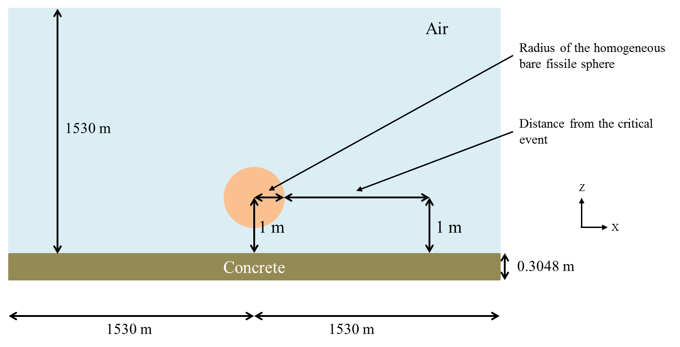
50 cm

Figure 1 : X-Z Plan view of the configuration

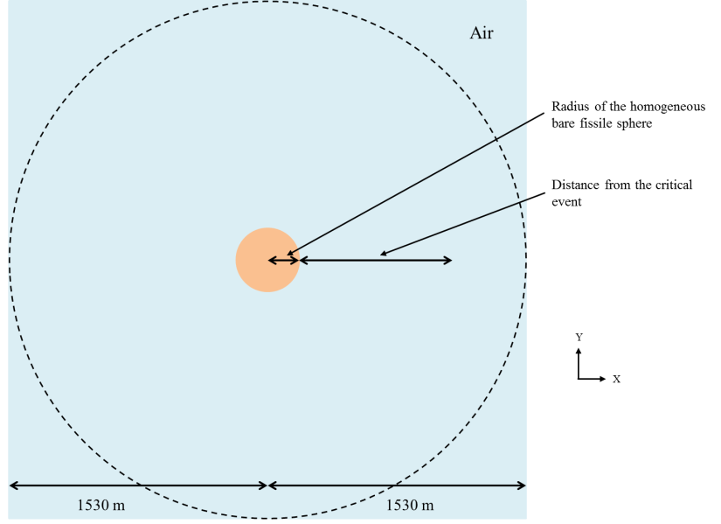

Figure 2 : X-Y Plan view of the configuration

Plutonium systems (bare sphere)
New bare fissile media, with plutonium at various moderation ratios (H/Pu), is added for the additional configurations. No reflector is considered around the sphere. The following table gives atomic concentration and critical radius of each media.
Table 1 : Compositions for the new fissile media, Pu
Number density  (atom/barn-cm) | Pu  (H/Pu = 0) | Pu  (H/Pu = 10) | Pu  (H/Pu = 100) | Pu  (H/Pu = 900) | Pu  (H/Pu = 2000)
Pu-239 | 5.00305E-02 | 5.88706E-03 | 6.58436E-04 | 7.40255E-05 | 3.33386E-05
O-16 | 0 | 2.94353E-02 | 3.29218E-02 | 3.33115E-02 | 3.33386E-02
H-1 | 0 | 5.88706E-02 | 6.58436E-02 | 6.66230E-02 | 6.66772E-02

The following table gives critical radii for these five media. They are calculated using MCNP6.1 with ENDF/B-VII.1 cross sections library.
Table 2 : Spherical radii for bare Pu configurations
 | Pu  H/Pu = 0 | Pu  H/Pu = 10 | Pu  H/Pu = 100 | Pu  H/Pu = 900 | Pu  H/Pu = 2000
Spherical radius (cm) | 4.93 | 12.53 | 15.36 | 19.50 | 29.17

new geometry source (cylinders)
The initial configurations of the Slide Rule considered bare spherical systems for the source. In these additional configurations, critical cylinders are also considered. No reflector is considered around the cylinder. Three types of vertical cylinder, with various height-to-diameter ratios, are considered. The following table gives critical dimensions for plutonium systems.

Table 3 : Critical dimensions for Pu cylinders
 | Height-to-diameter ratio | Pu  H/Pu = 0 | Pu  H/Pu = 10 | Pu  H/Pu = 100 | Pu  H/Pu = 900 | Pu  H/Pu = 2000
Radius 1 (cm) | 1 | 4.42 | - | - | - | 26.62
Height 1 (cm) |  | 8.84 | - | - | - | 53.24
Radius 2 (cm) | 0.5 | 5.81 | - | - | - | 36.09
Height 2 (cm) |  | 5.81 | - | - | - | 36.09
Radius 3 (cm) | 2 | 3.775 | - | - | - | 23.25
Height 3 (cm) |  | 15.10 | - | - | - | 93.00

Reflector (steel)
The initial configurations of the Slide Rule considered bare spherical systems for the source. In these additional configurations, steel reflector is added around the plutonium sphere, which modifies the critical radius of Plutonium.
The reflector’s atomic composition is presented in the following table. The “Steel 304” from the PNNL document is arbitrarily chosen. The thickness of the reflector will be 0.1 cm, 0.3 cm, 1 cm, 5 cm, 10 cm and 20 cm.
The distance between the source and the detector is measured from the external surface of the steel to the center of the detector.

Table 4 : Composition of the reflector
Number density  (atom/barn-cm) | Steel 304 PNNL
C-12 | 1.6000E-04
Si-28 | 7.9133E-04
Si-29 | 4.0180E-05
Si-30 | 2.6490E-05
P-31 | 3.6000E-05
S-32 | 2.1834E-05
S-33 | 1.7480E-07
S-34 | 9.8670E-07
S-36 | 4.5000E-09
Cr-50 | 7.6494E-04
Cr-52 | 1.4751E-02
Cr-53 | 1.6727E-03
Cr-54 | 4.1636E-04
Mn-55 | 8.7700E-04
Fe-54 | 3.5380E-03
Fe-56 | 5.5546E-02
Fe-57 | 1.2830E-03
Fe-58 | 1.7100E-04
Ni-58 | 5.1691E-03
Ni-60 | 1.9911E-03
Ni-61 | 8.6500E-05
Ni-62 | 2.7600E-04
Ni-64 | 7.0300E-05

Critical radii for each configuration are given in the following table. They are calculated using MCNP6.1 with ENDF/B-VII.1 cross sections library.
Table 5 : Critical radii for Pu sphere with a reflector
Reflector composition | Thickness of the reflector | Critical radius of Plutonium (cm)
 |  | Pu  H/Pu = 0 | Pu  H/Pu = 10 | Pu  H/Pu = 100 | Pu  H/Pu = 900 | Pu  H/Pu = 2000
Steel 304 PNNL | 0.1 cm | 4.89 | - | - | - | 29.10
 | 0.3 cm | 4.82 | - | - | - | 29.01
 | 1 cm | 4.62 | - | - | - | 28.31
 | 5 cm | 4.22 | - | - | - | 26.31
 | 10 cm | 4.05 | - | - | - | 25.31
 | 20 cm | 3.95 | - | - | - | 24.31

Additional information

Source Strength and Spectra
The magnitude of each source is normalized to correspond to 1.E+17 fissions. This single information means that the intensity (nubar for neutron) and the energy and space repartition of prompt neutron and prompt gamma inside the sphere/cylinder has to be determined.

Material and temperature Data
Depending on the case, only 3 or 4 media are simulated in the additional configurations:
- The air,
- One of the homogeneous plutonium spheres or cylinders,
- The reflector made of steel, for the reflector cases,
- The ground made of concrete.
The atomic compositions of the air and the ground made of concrete are given in the following tables.

Table 6 : Composition of air.
Number density  (atom/barn-cm) | Air
N-14 | 4.00E-5
O-16 | 1.11E-5

Table 7 : Composition of concrete (SCALE material REG-CONCRETE).
Number density  (atom/barn-cm) | Concrete
Fe-54 | 2.02958E-05
Fe-56 | 3.18600E-04
Fe-57 | 7.35787E-06
Fe-58 | 9.79198E-07
H-1 | 1.37433E-02
Al-27 | 1.74538E-03
Ca-40 | 1.47412E-03
Ca-42 | 9.83851E-06
Ca-43 | 2.05286E-06
Ca-44 | 3.17205E-05
Ca-46 | 6.08254E-08
Ca-48 | 2.84359E-06
O-16 | 4.60690E-02
Si-28 | 1.53273E-02
Si-29 | 7.78639E-04
Si-30 | 5.13885E-04
Na-23 | 1.74720E-03

The temperatures for all media and for all cases are 300 K (26.85 °C).

Delayed gamma
For these configurations, the delayed gamma are not considered. Only prompt doses are calculated.

response function and detectors
Henderson flux to dose conversion factors was used for the initial configurations. These factors have a significant impact on the final dose and are likely to change in the future. That is why, the additional configurations should be performed using the following conversion factors:
- ANSI/HPS N13.3-2013 conversion factors (personal adsorbed dose per neutron unit fluence, Table B1 p. 18 and personal adsorbed dose per photon unit fluence, Table B2 p. 19),
- IAEA Technical Reports series n° 211 (1982) conversion factors (tissue kerma in air per neutron unit fluence, Table XIV pp. 138-139),
- ICRU report 47 (1992) conversion factors (air kerma in free air per photon unit fluence, Table A.1 p. 23),
- a fine group structure for neutron and gamma spectra, provided in annex 1. With these structures, it will be possible to apply any kind of flux to dose conversion factors in the future.

Doses are calculated (see figure 1) at 1 m above the ground as a function of distance (between 30 cm and 1 200 m) from the external surface of the source to the center of the detector. The detector used (type and geometry) might be specified. By default, the detector geometry is a shape of a cylindrical shell with a square cross-section of 5 cm x 5 cm. The center of the detector is also at a height of 1 m above the ground.

RESULTS
The results will be written in the following tables. All options and data necessary to analyze the results (for instance, cross section libraries, kind of detector, use of variance reduction technique, etc.) might be specified.
For more clarity, a common file naming convention may be adopted. An example is the following:
- SR-Pu-S-UN-G1-C1-d03-N.inp stands for:
- SR: slide rule,
- Pu: Plutonium,
- S : sphere
- UN: unreflected (no shielding),
- G1: first case with a ground,
- C1: first case with the plutonium system (H/Pu = 0),
- d03: distance 0.3 m,
- N: prompt neutron.

Table 8 : Prompt neutron dose for bare plutonium configuration
Prompt neutron dose | Case 1 | Case 2 | Case 3 | Case 4 | Case 5
Distance (m) | Pu  H/Pu = 0 | Pu  H/Pu = 10 | Pu  H/Pu = 100 | Pu  H/Pu = 900 | Pu  H/Pu = 2000
0.3
0.5
1
2
5
10
20
50
100
200
300
500
700
1000
1200

Table 9 : Prompt gamma dose for bare plutonium configuration.
Prompt gamma dose | Case 1 | Case 2 | Case 3 | Case 4 | Case 5
Distance (m) | Pu  H/Pu = 0 | Pu  H/Pu = 10 | Pu  H/Pu = 100 | Pu  H/Pu = 900 | Pu  H/Pu = 2000
0.3
0.5
1
2
5
10
20
50
100
200
300
500
700
1000
1200
Table 10 : Prompt neutron dose for cylinder plutonium configuration.
Prompt neutron dose | Case 1 | Case 5 | Case 1 | Case 5 | Case 1 | Case 5
Cylinder | Cylinder 1 |  | Cylinder 2 |  | Cylinder 3
Distance (m) | Pu  H/Pu = 0 | Pu  H/Pu = 2000 | Pu  H/Pu = 0 | Pu  H/Pu = 2000 | Pu  H/Pu = 0 | Pu  H/Pu = 2000
0.3
0.5
1
2
5
10
20
50
100
200
300
500
700
1000
1200

Table 11 : Prompt gamma dose for cylinder plutonium configuration.
Prompt gamma dose | Case 1 | Case 5 | Case 1 | Case 5 | Case 1 | Case 5
Cylinder | Cylinder 1 |  | Cylinder 2 |  | Cylinder 3
Distance (m) | Pu  H/Pu = 0 | Pu  H/Pu = 2000 | Pu  H/Pu = 0 | Pu  H/Pu = 2000 | Pu  H/Pu = 0 | Pu  H/Pu = 2000
0.3
0.5
1
2
5
10
20
50
100
200
300
500
700
1000
1200

Table 12 : Prompt neutron dose for reflected plutonium configuration.
Prompt neutron dose | Case 1 | Case 5 | Case 1 | Case 5 | Case 1 | Case 5 | Case 1 | Case 5 | Case 1 | Case 5 | Case 1 | Case 5
Reflector | 0.1 cm | 0.1 cm | 0.3 cm | 0.3 cm | 1 cm | 1 cm | 5 cm | 5 cm | 10 cm | 10 cm | 20 cm | 20 cm
Distance (m) | Pu  H/Pu = 0 | Pu  H/Pu=2000 | Pu  H/Pu = 0 | Pu  H/Pu=2000 | Pu  H/Pu = 0 | Pu  H/Pu=2000 | Pu  H/Pu = 0 | Pu  H/Pu=2000 | Pu  H/Pu = 0 | Pu  H/Pu=2000 | Pu  H/Pu = 0 | Pu  H/Pu=2000
0.3
0.5
1
2
5
10
20
50
100
200
300
500
700
1000
1200

Table 13 : Prompt gamma dose for reflected plutonium configuration.
Prompt gamma dose | Case 1 | Case 5 | Case 1 | Case 5 | Case 1 | Case 5 | Case 1 | Case 5 | Case 1 | Case 5 | Case 1 | Case 5
Reflector | 0.1 cm | 0.1 cm | 0.3 cm | 0.3 cm | 1 cm | 1 cm | 5 cm | 5 cm | 10 cm | 10 cm | 20 cm | 20 cm
Distance (m) | Pu  H/Pu = 0 | Pu  H/Pu=2000 | Pu  H/Pu = 0 | Pu  H/Pu=2000 | Pu  H/Pu = 0 | Pu  H/Pu=2000 | Pu  H/Pu = 0 | Pu  H/Pu=2000 | Pu  H/Pu = 0 | Pu  H/Pu=2000 | Pu  H/Pu = 0 | Pu  H/Pu=2000
0.3
0.5
1
2
5
10
20
50
100
200
300
500
700
1000
1200

Annex 1: group structure for neutron and gamma spectra

PNNL-15870 Rev. 1, “Compendium of Material Composition Data for Radiation Transport Modeling,” (2011).
Henderson flux to dose conversion factors might be used for some cases to compare the impact of the various conversion factors and the impact of the additional configurations compared to the initial configurations.
Pu is for Plutonium
CYL1, CYL2 or CYL3 stands for cylinders
R stands for reflected configurations (steel here).
G1 is for concrete ground.
C2 is H/Pu = 10; C3 is H/Pu = 100; C4 is H/Pu = 900; C5 is H/Pu = 2000.
« G » stands for prompt gamma.

