UPDATE OF THE NUCLEAR CRITICALITY SLIDE RULE CALCULATIONS
–
SENSITIVITY STUDIES

IDENTIFICATION NUMBER: SR-U-MOISTURE-GROUND-001,
SR-U-UNREFLECTED-GROUND-002,
SR-U-SKYSHINE-GROUND-001,
SR-U-SCREEN-GROUND-001,

KEY WORDS: Slide rule, uranium, radiological screen

IntroDuction
In 1997, Oak Ridge National Laboratory published the reports “An updated Nuclear Criticality Slide rule” (ORNL/TM-13322/V1 and ORNL/TM-13322/V2), as a tool for emergency response to nuclear criticality accident. The “Slide Rule” is designed to provide estimates of the following:
- magnitude of the number of fissions based on personnel or field radiation measurements,
- neutron- and gamma-dose at variable unshielded distances from the accident,
- the skyshine component of the dose,
- time-integrated radiation dose estimates at variable times/distances from the accident,
- 1-minute gamma radiation dose integrals at variable times/distances from the accident,
- dose-reduction factors for variable thicknesses of steel, concrete, and water.
The Slide Rule provides estimates for five unreflected spherical systems that provide general characteristics of operations likely in facilities licensed by the US NRC. AWE (UK), IRSN (France), LLNL (USA) and ORNL (USA) began a long term collaboration effort in 2015 to update this document. Calculations for initial configurations were performed using modern tools such as MCNP, SCALE and COG.
This present document summarizes the input data necessary to update and complete the Slide Rule.

Description of the configurations

GEOMETRY
The geometry for the configuration of the slide rule (described in the document SR-U-UNREFLECTED-GROUND-001), is presented hereafter.
The geometry consists of a simple air-over-ground configuration with a source located at the center of a right-circular cylinder. The radius and the height of the air cylinder is 1530 m. With modern 3-D tools, a square with a half-side of 1530 m might be considered. The ground is now modeled as 50 cm layer of concrete.
The figures 1 and 2 present the model to be calculated. Additional information is given in the following paragraphs.
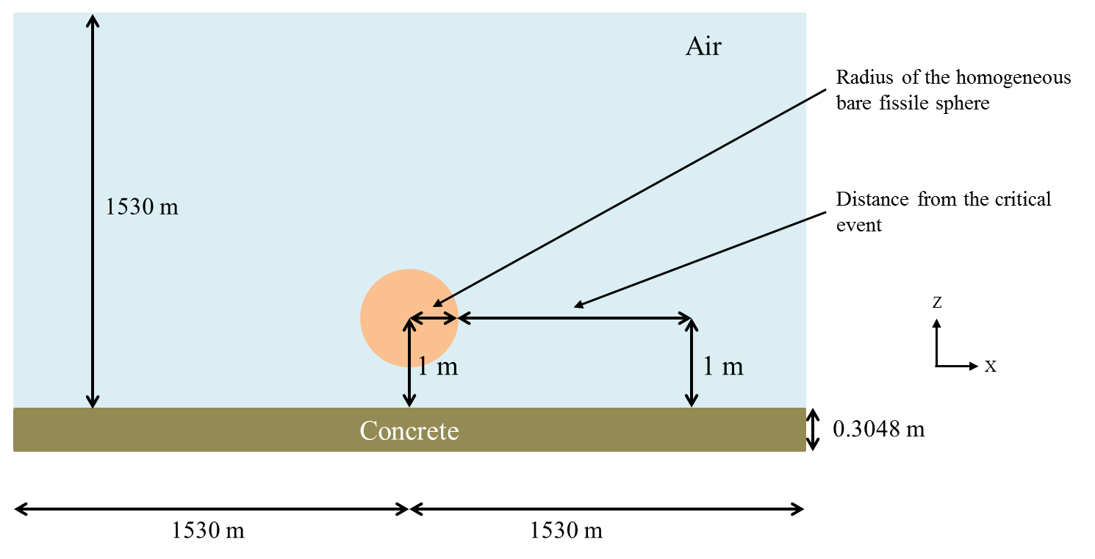
50 cm

Figure 1 : X-Z Plan view of the configuration
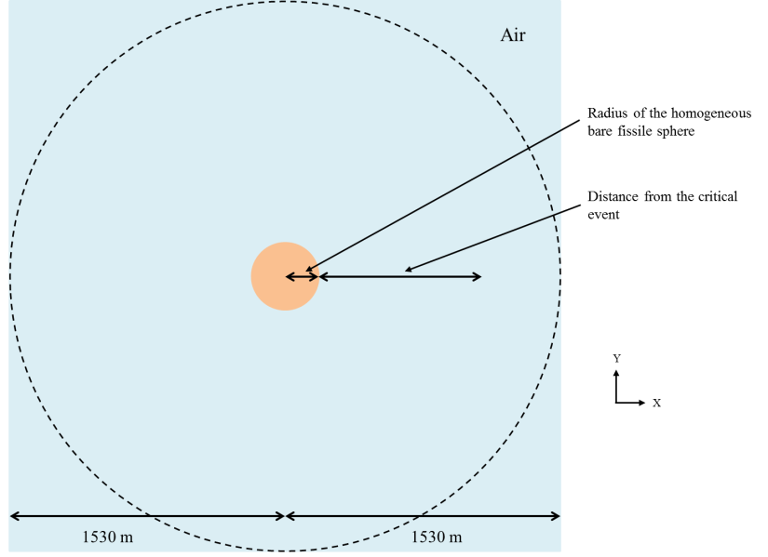

Figure 2 : X-Y Plan view of the configuration

Five uranium systems are separately considered. The spherical radius (corresponding to a critical state) for each system is given in Table 1. No reflector is considered around the sphere.

Table 1: Radius of the homogeneous bare fissile spheres.
 | Uranyl fluoride (4.95%) | Damp UO₂ (5%) | Uranyl nitrate solution (93.2%) | U metal (93.2%) | Damp U₃O₈ (93.2%)
Spherical radius (cm) | 25.5476 | 23.2133 | 18.9435 | 8.6518 | 11.8841

Material and temperature Data
3 media are simulated in the initial configuration:
- The air,
- One of the 5 homogeneous bare fissile spheres,
- The ground made of concrete.
Their atomic compositions are given in Table 2, Table 3 and Table 5.
Table 2: Composition of the homogeneous bare fissile spheres.
Number density  (atom/barn-cm) | Uranyl fluoride (4.95%) | Damp UO₂ (5%) | Uranyl nitrate solution (93.2%) | U metal (93.2%) | Damp U₃O₈ (93.2%)
U-234 | - | - | - | 4.8503E-4 | -
U-235 | 1.3173E-4 | 2.6060E-4 | 1.3154E-4 | 4.5012E-2 | 6.4361E-3
U-236 | - | - | - | 9.6182E-5 | -
U-238 | 2.5342E-3 | 4.9592E-3 | 9.6010E-6 | 2.6704E-3 | 4.6956E-4
N | - | - | 2.8205E-4 | - | -
O | 3.1989E-2 | 3.6544E-2 | 3.4012E-2 | - | 5.0641E-2
F | 5.3345E-3 | - | - | - | -
H | 5.3314E-2 | 5.2203E-2 | 6.5769E-2 | - | 6.4460E-2

Table 3: Composition of air.
Number density  (atom/barn-cm) | Air
N | 4.00E-5
O | 1.11E-5

The temperatures for all media are 300 K (26.85 °C).

Description of the Sensitivity Studies
This part presents the sensitivity studies to perform for the initial configurations of the Slide Rule.

Moisture in air
Neutron and gamma prompt dose calculations will be performed with a humidity of 10% and 100%, at the room temperature. The air composition to be used is given in the following table:

Table 4 : Composition of air – humidity of 10% and 100%
Number density  (atom/barn-cm) | Air  Humidity 10% | Air  Humidity 100%
N-14 | 3.9214E-05 | 3.8397E-05
O-16 | 1.0798E-05 | 1.1094E-05
H-1 | 1.1559E-07 | 1.1559E-06

Ground composition and dimensions
Calculations will be performed with the regulatory concrete composition, cf. Table 5. Nevertheless, a dry soil composition (without hydrogen) will be also tested for the case 1 and case 4, cf. Table 6. In each case, neutron and gamma prompt dose calculations should be performed. Moreover, the dimension for the ground is changed from 30.48 cm (initial configurations) to 50 cm. The following tables give atomic concentration of the concrete and the soil.

Table 5 : Composition of concrete (REGULAR-CONCRETE-NRC)
Number density  (atom/barn-cm) | Concrete
Fe-54 | 2.02958E-05
Fe-56 | 3.18600E-04
Fe-57 | 7.35787E-06
Fe-58 | 9.79198E-07
H | 1.37433E-02
Al-27 | 1.74538E-03
Ca-40 | 1.47412E-03
Ca-42 | 9.83851E-06
Ca-43 | 2.05286E-06
Ca-44 | 3.17205E-05
Ca-46 | 6.08254E-08
Ca-48 | 2.84359E-06
O | 4.60690E-02
Si-28 | 1.53273E-02
Si-29 | 7.78639E-04
Si-30 | 5.13885E-04
Na-23 | 1.74720E-03

Table 6 : Composition of soil (EARTH US average - PNNL)
Number density  (atom/barn-cm) | Soil
O-16 | 2.9391E-02
Na-23 | 2.4400E-04
Mg-24 | 3.9053E-04
Mg-25 | 5.1503E-05
Mg-26 | 5.8968E-05
Mg-27 | 2.3260E-03
Mg-28 | 8.1191E-03
Mg-29 | 4.2723E-04
Si-30 | 2.9165E-04
K-39 | 3.1134E-04
K-40 | 4.0200E-08
K-41 | 2.3621E-05
Ca-40 | 1.1300E-03
Ca-42 | 7.9141E-06
Ca-43 | 1.6951E-06
Ca-44 | 2.6747E-05
Ca-46 | 5.8450E-08
Ca-48 | 2.6186E-06
Ti-46 | 6.9696E-06
Ti-47 | 6.4222E-06
Ti-48 | 6.4984E-05
Ti-49 | 4.8682E-06
Ti-50 | 4.7564E-06
Mn-55 | 1.2000E-05
Fe-54 | 5.2113E-05
Fe-56 | 8.4826E-04
Fe-57 | 1.9937E-05
Fe-58 | 2.7044E-06

Skyshine
The contribution of the skyshine will be determined for height superior to 10 m in each configuration. It means that calculations of the 5 cases will be done again with a height of 10 m (instead of 1530 m). The effect of the skyshine is the different between the two calculations.

Radiological screen
A radiological screen will be added in each configuration. This screen will be placed at various distances between the source and the detector. The position of the radiological screen is measured from the external surface of the source to the internal face of the screen. The detector has a spherical shape with default radius of 20 cm.
Figure 3 : X-Z Plan view of the configuration with a radiological screen
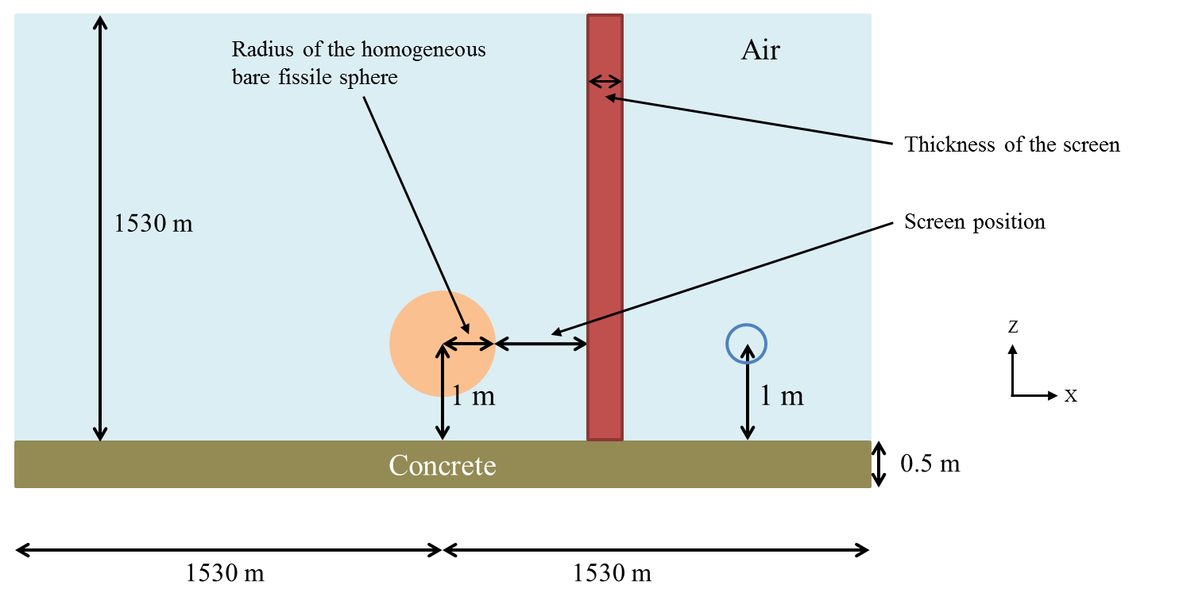

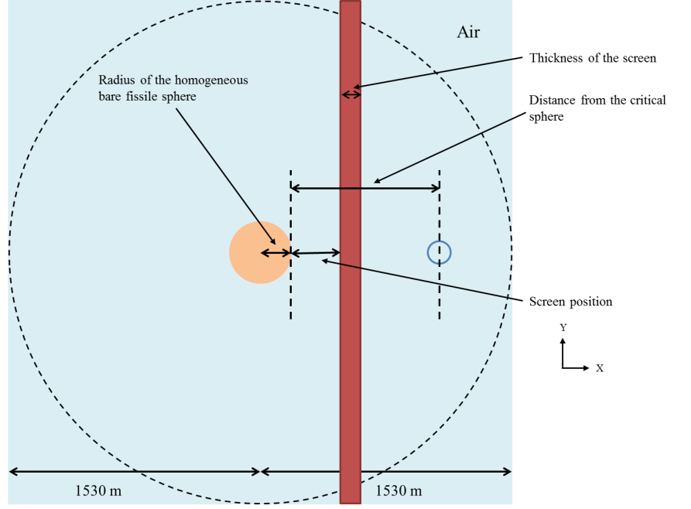
Figure 4 : X-Y Plan view of the configuration with a radiological screen

The following table presents screen positions for each detector distance.

Table 7 : Screen position for each detector
Detector position (m) | Screen position (m)
0.3
0.5
1 | 0.50
2 | 1.00
5 | 2.50
10 | 5.00
20 | 10.00
50 | 25.00
100 | 50.00
200 | 100.00
300 | 150.00
500 | 250.00
700 | 350.00
1000 | 500.00
1200 | 600.00

Compositions for the radiological screen are presented in the following table.

Table 8 : Compositions for the radiological screen
Number density  (atom/barn-cm) | Steel 304 PNNL | Number density  (atom/barn-cm) | Water PNNL | Number density  (atom/barn-cm) | Lead PNNL | Number density  (atom/barn-cm) | Concrete
C-6 | 1.6000E-04 | H | 6.6733E-02 | Pb-204 | 4.6183E-04 | Fe-54 | 2.02958E-05
P-31 | 3.6000E-05 | O-16 | 3.3368E-02 | Pb-206 | 7.9501E-03 | Fe-56 | 3.18600E-04
Mn-55 | 8.7700E-04 |  |  | Pb-207 | 7.2903E-03 | Fe-57 | 7.35787E-06
Si-28 | 7.8821E-04 |  |  | Pb-208 | 1.7286E-02 | Fe-58 | 9.79198E-07
Si-29 | 4.1476E-05 |  |  |  |  | H | 1.37433E-02
Si-30 | 2.8314E-05 |  |  |  |  | Al-27 | 1.74538E-03
S-32 | 2.1784E-05 |  |  |  |  | Ca-40 | 1.47412E-03
S-33 | 1.7733E-07 |  |  |  |  | Ca-42 | 9.83851E-06
S-34 | 1.0355E-06 |  |  |  |  | Ca-43 | 2.05286E-06
S-35 | 2.5300E-09 |  |  |  |  | Ca-44 | 3.17205E-05
Cr-50 | 7.6494E-04 |  |  |  |  | Ca-46 | 6.08254E-08
Cr-52 | 1.4751E-02 |  |  |  |  | Ca-48 | 2.84359E-06
Cr-53 | 1.6727E-03 |  |  |  |  | O | 4.60690E-02
Cr-54 | 4.1636E-04 |  |  |  |  | Si-28 | 1.53273E-02
Fe-54 | 3.4180E-03 |  |  |  |  | Si-29 | 7.78639E-04
Fe-56 | 5.5636E-02 |  |  |  |  | Si-30 | 5.13885E-04
Fe-57 | 1.3076E-03 |  |  |  |  | Na-23 | 1.74720E-03
Fe-58 | 1.7738E-04
Ni-58 | 5.1691E-03
Ni-60 | 1.9911E-03
Ni-61 | 8.6553E-05
Ni-62 | 2.7597E-04
Ni-64 | 7.0281E-05

The thickness of the screen is related to its composition. The following table presents those thicknesses.

Table 9 : Thickness of the radiological screen
Composition of the screen | Thickness (cm)
Steel 304 PNNL | 1 | 5 | 10 | 20
Lead PNNL | 1 | 5 | 10 | 20
Water | 1 | 5 | 10 | 20
Concrete | 20 | 40
Those thicknesses are representative of the different kind of wall, tank etc., that could be found in a nuclear facility

Response Functions
Henderson flux to dose conversion factors was used for the initial configurations. These factors have a significant impact on the final dose and are likely to change in the future. That is why, the additional configurations should be performed using the following conversion factors :
- ANSI/HPS N13.3-2013 conversion factors (personal adsorbed dose per neutron unit fluence, Table B1 p. 18 and personal adsorbed dose per photon unit fluence, Table B2 p. 19),
- Group structures defined in the Table 7 and Table 8 (only a measurement of the flux with these factors).

Table 10 : Upper bounds for neutron fine group structures (from left to right and top to bottom)
Upper bounds in MeV
1.00E-11 | 1.00E-09 | 2.15E-09 | 4.64E-09 | 1.00E-08 | 2.15E-08 | 2.50E-08
2.60E-08 | 3.00E-08 | 4.64E-08 | 5.00E-08 | 1.00E-07 | 2.00E-07 | 2.15E-07
2.25E-07 | 3.25E-07 | 4.15E-07 | 4.64E-07 | 5.00E-07 | 8.00E-07 | 1.00E-06
1.13E-06 | 1.30E-06 | 1.86E-06 | 2.00E-06 | 2.15E-06 | 3.06E-06 | 4.64E-06
5.00E-06 | 1.00E-05 | 1.07E-05 | 1.10E-05 | 2.00E-05 | 2.15E-05 | 2.90E-05
3.60E-05 | 4.64E-05 | 5.00E-05 | 6.30E-05 | 1.00E-04 | 1.01E-04 | 1.10E-04
2.00E-04 | 2.15E-04 | 3.60E-04 | 4.64E-04 | 5.00E-04 | 5.83E-04 | 6.30E-04
1.00E-03 | 1.10E-03 | 2.00E-03 | 2.15E-03 | 3.04E-03 | 3.60E-03 | 4.64E-03
5.00E-03 | 6.30E-03 | 1.00E-02 | 1.10E-02 | 1.25E-02 | 1.50E-02 | 1.58E-02
2.00E-02 | 2.51E-02 | 3.00E-02 | 3.16E-02 | 3.60E-02 | 3.98E-02 | 5.00E-02
5.01E-02 | 6.30E-02 | 7.00E-02 | 7.94E-02 | 8.20E-02 | 8.60E-02 | 9.00E-02
9.40E-02 | 9.80E-02 | 1.00E-01 | 1.05E-01 | 1.11E-01 | 1.15E-01 | 1.25E-01
1.35E-01 | 1.45E-01 | 1.50E-01 | 1.55E-01 | 1.58E-01 | 1.65E-01 | 1.75E-01
1.85E-01 | 1.95E-01 | 2.00E-01 | 2.10E-01 | 2.30E-01 | 2.50E-01 | 2.51E-01
2.70E-01 | 2.90E-01 | 3.00E-01 | 3.10E-01 | 3.16E-01 | 3.30E-01 | 3.50E-01
3.70E-01 | 3.90E-01 | 3.98E-01 | 4.00E-01 | 4.08E-01 | 4.20E-01 | 4.50E-01
4.60E-01 | 5.00E-01 | 5.01E-01 | 5.40E-01 | 5.50E-01 | 5.80E-01 | 6.00E-01
6.20E-01 | 6.30E-01 | 6.60E-01 | 7.00E-01 | 7.40E-01 | 7.80E-01 | 7.94E-01
8.00E-01 | 8.20E-01 | 8.60E-01 | 9.00E-01 | 9.07E-01 | 9.40E-01 | 9.80E-01
1.00E+00 | 1.05E+00 | 1.10E+00 | 1.15E+00 | 1.20E+00 | 1.25E+00 | 1.30E+00
1.35E+00 | 1.40E+00 | 1.43E+00 | 1.45E+00 | 1.50E+00 | 1.55E+00 | 1.58E+00
1.60E+00 | 1.65E+00 | 1.70E+00 | 1.75E+00 | 1.80E+00 | 1.83E+00 | 1.85E+00
1.90E+00 | 1.95E+00 | 2.00E+00 | 2.10E+00 | 2.20E+00 | 2.30E+00 | 2.40E+00
2.50E+00 | 2.60E+00 | 2.70E+00 | 2.80E+00 | 2.90E+00 | 3.00E+00 | 3.10E+00
3.15E+00 | 3.20E+00 | 3.30E+00 | 3.40E+00 | 3.50E+00 | 3.60E+00 | 3.70E+00
3.75E+00 | 3.80E+00 | 3.90E+00 | 4.00E+00 | 4.10E+00 | 4.20E+00 | 4.30E+00
4.50E+00 | 4.60E+00 | 4.70E+00 | 4.80E+00 | 4.90E+00 | 5.00E+00 | 5.10E+00
5.20E+00 | 5.30E+00 | 5.40E+00 | 5.50E+00 | 5.60E+00 | 5.80E+00 | 6.00E+00
6.20E+00 | 6.30E+00 | 6.40E+00 | 6.50E+00 | 6.60E+00 | 6.70E+00 | 7.00E+00
7.30E+00 | 7.40E+00 | 7.50E+00 | 7.70E+00 | 7.80E+00 | 7.94E+00 | 8.00E+00
8.20E+00 | 8.30E+00 | 8.50E+00 | 8.60E+00 | 9.00E+00 | 9.40E+00 | 9.80E+00
1.00E+01 | 1.05E+01 | 1.10E+01 | 1.15E+01 | 1.20E+01 | 1.25E+01 | 1.30E+01
1.35E+01 | 1.40E+01 | 1.45E+01 | 1.50E+01 | 1.60E+01 | 1.70E+01 | 1.80E+01
2.00E+01

Table 11 : Upper bounds for gamma fine group structures (from left to right and top to bottom)
Upper bounds in MeV
1.00E-02 | 1.25E-02 | 1.50E-02 | 1.75E-02 | 2.00E-02 | 2.50E-02 | 3.00E-02
4.00E-02 | 4.50E-02 | 5.00E-02 | 6.00E-02 | 7.00E-02 | 8.00E-02 | 1.00E-01
1.25E-01 | 1.50E-01 | 2.00E-01 | 2.50E-01 | 3.00E-01 | 3.50E-01 | 4.00E-01
4.50E-01 | 5.00E-01 | 5.50E-01 | 6.00E-01 | 6.50E-01 | 7.00E-01 | 8.00E-01
1.00E+00 | 1.10E+00 | 1.20E+00 | 1.33E+00 | 1.40E+00 | 1.50E+00 | 1.66E+00
1.80E+00 | 2.00E+00 | 2.20E+00 | 2.50E+00 | 2.60E+00 | 2.80E+00 | 3.00E+00
3.25E+00 | 3.50E+00 | 3.75E+00 | 4.00E+00 | 4.25E+00 | 4.50E+00 | 4.75E+00
5.00E+00 | 5.25E+00 | 5.50E+00 | 5.75E+00 | 6.00E+00 | 6.25E+00 | 6.50E+00
6.75E+00 | 7.50E+00 | 8.00E+00 | 8.50E+00 | 9.00E+00 | 9.50E+00 | 1.00E+01
1.10E+01 | 1.30E+01 | 1.50E+01 | 2.00E+01

Doses are calculated (see figure 1) at 1 m above the ground as a function of distance (between 30 cm and 1 200 m) from the external surface of the source to the center of the detector. The detector used (type and geometry) might be specified. By default (for configurations without a radiological screen), the detector geometry is a shape of a cylindrical shell with a square cross-section of 5 cm x 5 cm. The center of the detector is also at a height of 1 m above the ground.

RESULTS
The results will be written in the following tables. All options and data necessary to analyze the results (for instance, cross section libraries, delayed gamma data, kind of detector, use of variance reduction technique, etc.) might be specified.
For more clarity, a common file naming convention may be adopted. An example is the following:
- SR-U-UN-G1-C1-d03-DG10s.inp stands for:
- SR: slide rule,
- U: uranium,
- UN: unreflected (no shielding),
- G1: first case with a ground,
- C1: first case with the uranium system (Uranyl fluoride (4.95%)),
- d03: distance 0.3 m,
- DG10s: delayed gamma (after 10 seconds).

The air composition is based on the reference “Air humide – Notions de base et mesures. Réf : BZ8025 V1. Bernard CRETINON, Bertrand BLANQUART”.
Soil composition is taken from the Pacific Northwest National Laboratory “Compendium of Material Composition Data for Radiation Transport Modeling” Revision 1 March, 2011. Concrete composition was defined by the Nuclear Regulatory Commission and it is the standard concrete in SCALE.
Compositions (except concrete) are taken from the Pacific Northwest National Laboratory ‘Compendium of Material Composition Data for Radiation Transport Modeling’ Revision 1 March, 2011
Pu is for Plutonium
R stand for reflected configurations.
G1 is for concrete ground, G2 stand for a soil ground.
C2 is Damp UO2 (5%); C3 is Uranyl nitrate solution (93.2%); C4 is U metal (93.2%); C5 is Damp U3O8 (93.2%); C6 is Pu.
Instead of « DG », « N » and « G » may be used, for respectively prompt neutron and prompt gamma.

