UPDATE OF THE NUCLEAR CRITICALITY SLIDE RULE CALCULATIONS
–
INITIAL CONFIGURATIONS

IDENTIFICATION NUMBER: SR-U-UNREFLECTED-GROUND-001
KEY WORDS: Slide rule, initial configurations, uranium, unreflected

INTRODUCTION
In 1997, Oak Ridge National Laboratory published the reports “An updated Nuclear Criticality Slide rule” (ORNL/TM-13322/V1 and ORNL/TM-13322/V2), as a tool for emergency response to nuclear criticality accident. The “Slide Rule” is designed to provide estimates of the following:
- magnitude of the number of fissions based on personnel or field radiation measurements,
- neutron- and gamma-dose at variable unshielded distances from the accident,
- the skyshine component of the dose,
- time-integrated radiation dose estimates at variable times/distances from the accident,
- 1-minute gamma radiation dose integrals at variable times/distances from the accident,
- dose-reduction factors for variable thicknesses of steel, concrete, and water.
The Slide Rule provides estimates for five unreflected spherical systems that provide general characteristics of operations likely in facilities licensed by the US NRC.
This present document summarizes the input data necessary to update, with modern codes, the dose results of the initial configurations of the slide rules (prompt neutron and gamma doses, delayed gamma dose). Additional configurations might be simulated after this first effort.

DESCRIPTION OF THE INITIAL CONFIGURATION
The geometry for the initial configuration of the slide rule consists of an air-over-ground configuration with a source located at the center of a right-circular cylinder. The ground is made of concrete. The critical uranium systems selected were as follows:
- unreflected sphere of 4.95 wt % enriched aqueous uranyl fluoride, U(4.95)O₂F₂@H₂O, solution having a hydrogen-to-²³⁵U ratio of 410 (solution density = 2.16 g/cm³),
- unreflected sphere of damp 5 wt % enriched uranium dioxide, U(5)O₂, having a hydrogen-to- ²³⁵U ratio of 200,
- unreflected sphere of 93.2 wt % enriched uranyl nitrate, U(93.2)O₂(NO₃)2@6H₂O, solution having a hydrogen to-²³⁵U atom ratio of 500 (solution density = 1.075 g/cm³),
- unreflected sphere of 93.2 wt % enriched uranium metal sphere (metal density = 18.85 g/cm³),
- unreflected sphere of damp 93.2 wt % enriched uranium oxide, U₃O₈ plus water, having a hydrogen-to- ²³⁵U atom ratio of 10 (uranium oxide density = 4.15 g/cm³).
Neutron and gamma doses were calculated as a function of distance from the surface of the critical event for 1 to 3000 feet (914 m).

Description of Model
The figures 2-1 and 2-2 present the model to be calculated. Additional information are given in the following paragraphs.
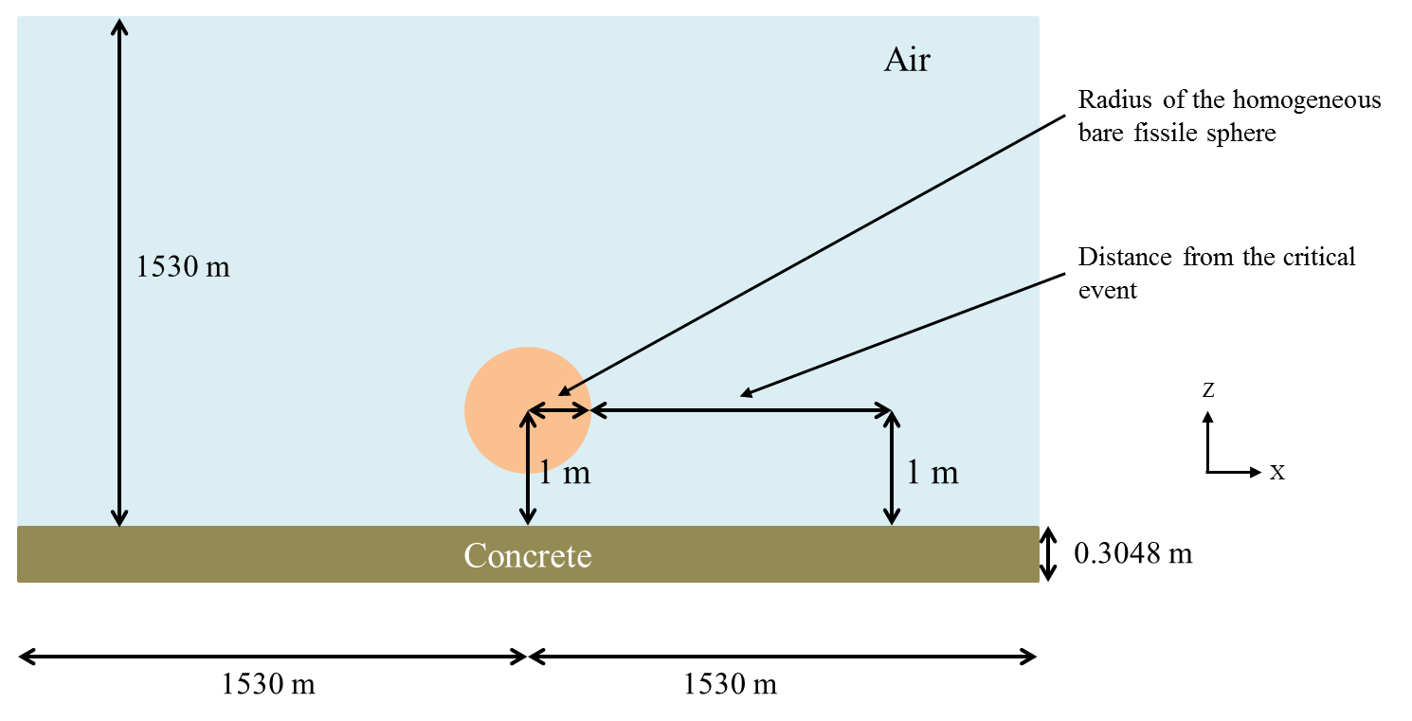
Figure 2-1. X-Z Plan view of the configuration.
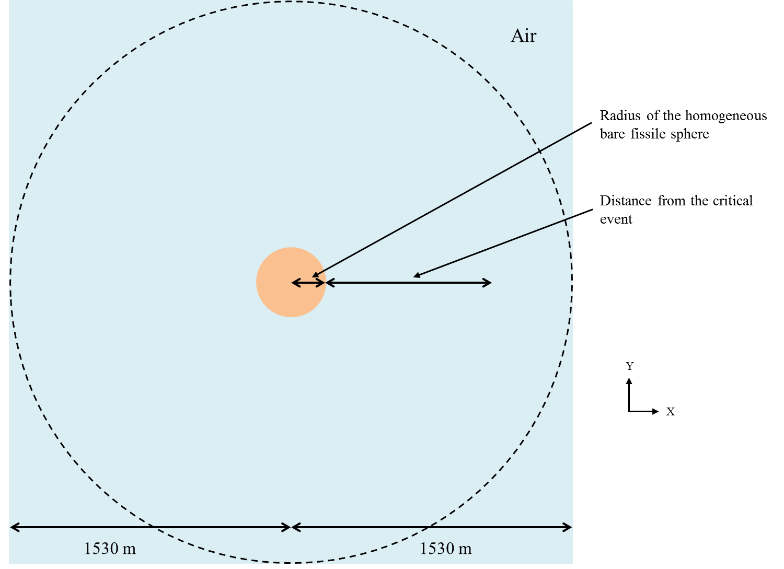
Figure 2-2. X-Y Plan view of the configuration.

Dimensions
Initially, the geometry for the 2-D slide-rule models consisted of a simple air-over-ground configuration with a source located at the center of a right-circular cylinder. The radius and the height of the air cylinder was 1530 m. With modern 3-D tools, a square with a half-side of 1530 m might be considered. The ground is modeled as 30.48 cm (1 ft) layer of concrete.
Five uranium systems are separately considered. The spherical radius (corresponding to a critical state) for each system is given in Table 2-1. No reflector is considered around the sphere.
Table 2-1. Radius of the homogeneous bare fissile spheres.
 | Uranyl fluoride (4.95%) | Damp UO₂ (5%) | Uranyl nitrate solution (93.2%) | U metal (93.2%) | Damp U₃O₈ (93.2%)
Spherical radius (cm) | 25.5476 | 23.2133 | 18.9435 | 8.6518 | 11.8841

Material and temperature Data
Only 3 media are simulated in the initial configurations:
- The air,
- One of the 5 homogeneous bare fissile spheres,
- The ground made of concrete.
Their atomic compositions are given in Table 2-2, Table 2-3 and Table 2-4.
Table 2-2. Composition of the homogeneous bare fissile spheres.
Number density  (atom/barn-cm) | Uranyl fluoride (4.95%) | Damp UO₂ (5%) | Uranyl nitrate solution (93.2%) | U metal (93.2%) | Damp U₃O₈ (93.2%)
U-234 | - | - | - | 4.8503E-4 | -
U-235 | 1.3173E-4 | 2.6060E-4 | 1.3154E-4 | 4.5012E-2 | 6.4361E-3
U-236 | - | - | - | 9.6182E-5 | -
U-238 | 2.5342E-3 | 4.9592E-3 | 9.6010E-6 | 2.6704E-3 | 4.6956E-4
N | - | - | 2.8205E-4 | - | -
O | 3.1989E-2 | 3.6544E-2 | 3.4012E-2 | - | 5.0641E-2
F | 5.3345E-3 | - | - | - | -
H | 5.3314E-2 | 5.2203E-2 | 6.5769E-2 | - | 6.4460E-2

Table 2-3. Composition of air.
Number density  (atom/barn-cm) | Air
N | 4.00E-5
O | 1.11E-5

Table 2-4. Composition of concrete (SCALE material REG-CONCRETE).
Number density  (atom/barn-cm) | Concrete
Fe-54 | 2.02958E-05
Fe-56 | 3.18600E-04
Fe-57 | 7.35787E-06
Fe-58 | 9.79198E-07
H | 1.37433E-02
Al-27 | 1.74538E-03
Ca-40 | 1.47412E-03
Ca-42 | 9.83851E-06
Ca-43 | 2.05286E-06
Ca-44 | 3.17205E-05
Ca-46 | 6.08254E-08
Ca-48 | 2.84359E-06
O | 4.60690E-02
Si-28 | 1.53273E-02
Si-29 | 7.78639E-04
Si-30 | 5.13885E-04
Na-23 | 1.74720E-03

The temperatures for all media are 300 K (26.85 °C).

Source Strength and Spectra
The magnitude of each source is normalized to correspond to 1.E+17 fissions.
This single information means that the intensity (nubar for neutron) and the energy and space repartition of prompt neutron, prompt gamma and delayed gamma inside the sphere has to be determined. A subsequent case may consider a homogeneous repartition of the fissions inside the sphere.

Delayed gamma
Delayed gamma doses rate are calculated assuming an instantaneous event. Then the expected dose rates for periods of 1, 5, and 10 s and 1, 5, 10, 50, 100, 500, and 1000 min after the event are tabulated for all five critical systems.

Response Functions
Doses at 1 m (3.30 ft) above the ground as a function of distance from the surface of the critical event for 1 to 3000 feet are calculated using the Henderson flux-to-dose factors (B. J. Henderson, Conversion of Neutron or Gamma-Ray Flux to Absorbed Dose Rate, XDC 59-8-179, 1959).

RESULTS
The results will be written in the following tables. All options and data necessary to analyze the results (for instance, cross section libraries, delayed gamma data, kind of detector, use of variance reduction technic, etc.) might be specified.
For more clarity, a common file naming convention may be adopted. An example is the following:
- SR-U-UN-G1-C1-d03-DG10s.inp stands for:
- SR: slide rule,
- U: uranium,
- UN: unreflected (no shielding),
- G1: first case with a ground,
- C1: first case with the uranium system (Uranyl fluoride (4.95%)),
- d03: distance 0.3 m,
- DG10s: delayed gamma (after 10 seconds).

Table 3-1. Prompt neutron dose.
Prompt neutron dose | Case 1 | Case 2 | Case 3 | Case 4 | Case 5
Distance (m) | Uranyl fluoride (4.95%) | Damp UO₂ (5%) | Uranyl nitrate solution (93.2%) | U metal (93.2%) | Damp U₃O₈ (93.2%)
0.3
0.5
1
2
5
10
20
50
100
200
300
500
700
1000
1200

Table 3-2. Prompt gamma dose.
Prompt gamma dose | Case 1 | Case 2 | Case 3 | Case 4 | Case 5
Distance (m) | Uranyl fluoride (4.95%) | Damp UO₂ (5%) | Uranyl nitrate solution (93.2%) | U metal (93.2%) | Damp U₃O₈ (93.2%)
0.3
0.5
1
2
5
10
20
50
100
200
300
500
700
1000
1200

Table 3-3. Delayed gamma dose rate (after 1 s).
Delayed gamma dose rate (after 1 s) | Case 1 | Case 2 | Case 3 | Case 4 | Case 5
Distance (m) | Uranyl fluoride (4.95%) | Damp UO₂ (5%) | Uranyl nitrate solution (93.2%) | U metal (93.2%) | Damp U₃O₈ (93.2%)
0.3
0.5
1
2
5
10
20
50
100
200
300
500
700
1000
1200

Table 3-4. Delayed gamma dose rate (after 5 s).
Delayed gamma dose rate (after 5 s) | Case 1 | Case 2 | Case 3 | Case 4 | Case 5
Distance (m) | Uranyl fluoride (4.95%) | Damp UO₂ (5%) | Uranyl nitrate solution (93.2%) | U metal (93.2%) | Damp U₃O₈ (93.2%)
0.3
0.5
1
2
5
10
20
50
100
200
300
500
700
1000
1200

Table 3-5. Delayed gamma dose rate (after 10 s).
Delayed gamma dose rate (after 10 s) | Case 1 | Case 2 | Case 3 | Case 4 | Case 5
Distance (m) | Uranyl fluoride (4.95%) | Damp UO₂ (5%) | Uranyl nitrate solution (93.2%) | U metal (93.2%) | Damp U₃O₈ (93.2%)
0.3
0.5
1
2
5
10
20
50
100
200
300
500
700
1000
1200

Table 3-6. Delayed gamma dose rate (after 1 min).
Delayed gamma dose rate (after 1 min) | Case 1 | Case 2 | Case 3 | Case 4 | Case 5
Distance (m) | Uranyl fluoride (4.95%) | Damp UO₂ (5%) | Uranyl nitrate solution (93.2%) | U metal (93.2%) | Damp U₃O₈ (93.2%)
0.3
0.5
1
2
5
10
20
50
100
200
300
500
700
1000
1200

Table 3-7. Delayed gamma dose rate (after 5 min).
Delayed gamma dose rate (after 5 min) | Case 1 | Case 2 | Case 3 | Case 4 | Case 5
Distance (m) | Uranyl fluoride (4.95%) | Damp UO₂ (5%) | Uranyl nitrate solution (93.2%) | U metal (93.2%) | Damp U₃O₈ (93.2%)
0.3
0.5
1
2
5
10
20
50
100
200
300
500
700
1000
1200

Table 3-8. Delayed gamma dose rate (after 10 min).
Delayed gamma dose rate (after 10 min) | Case 1 | Case 2 | Case 3 | Case 4 | Case 5
Distance (m) | Uranyl fluoride (4.95%) | Damp UO₂ (5%) | Uranyl nitrate solution (93.2%) | U metal (93.2%) | Damp U₃O₈ (93.2%)
0.3
0.5
1
2
5
10
20
50
100
200
300
500
700
1000
1200

Table 3-9. Delayed gamma dose rate (after 50 min).
Delayed gamma dose rate (after 50 min) | Case 1 | Case 2 | Case 3 | Case 4 | Case 5
Distance (m) | Uranyl fluoride (4.95%) | Damp UO₂ (5%) | Uranyl nitrate solution (93.2%) | U metal (93.2%) | Damp U₃O₈ (93.2%)
0.3
0.5
1
2
5
10
20
50
100
200
300
500
700
1000
1200

Table 3-10. Delayed gamma dose rate (after 100 min).
Delayed gamma dose rate (after 100 min) | Case 1 | Case 2 | Case 3 | Case 4 | Case 5
Distance (m) | Uranyl fluoride (4.95%) | Damp UO₂ (5%) | Uranyl nitrate solution (93.2%) | U metal (93.2%) | Damp U₃O₈ (93.2%)
0.3
0.5
1
2
5
10
20
50
100
200
300
500
700
1000
1200

Table 3-11. Delayed gamma dose rate (after 500 min).
Delayed gamma dose rate (after 500 min) | Case 1 | Case 2 | Case 3 | Case 4 | Case 5
Distance (m) | Uranyl fluoride (4.95%) | Damp UO₂ (5%) | Uranyl nitrate solution (93.2%) | U metal (93.2%) | Damp U₃O₈ (93.2%)
0.3
0.5
1
2
5
10
20
50
100
200
300
500
700
1000
1200

Table 3-12. Delayed gamma dose rate (after 1000 min).
Delayed gamma dose rate (after 1000 min) | Case 1 | Case 2 | Case 3 | Case 4 | Case 5
Distance (m) | Uranyl fluoride (4.95%) | Damp UO₂ (5%) | Uranyl nitrate solution (93.2%) | U metal (93.2%) | Damp U₃O₈ (93.2%)
0.3
0.5
1
2
5
10
20
50
100
200
300
500
700
1000
1200

C2 is Damp UO2 (5%); C3 is Uranyl nitrate solution (93.2%); C4 is U metal (93.2%); C5 is Damp U3O8 (93.2%).
Instead of « DG », « N » and « G » may be used, for respectively prompt neutron and prompt gamma.

